
OSA Data Assessment Report
Personal details | Gender: | M | Age: | 53 | Weight & Height: | 80 kg (176 lbs)  172 cm (7.7'5)
 |  |  |  |  | BMI: | 27.04

Clinical background: | No significant medical history reported, aside from Atorvastatin use.
ENT and DISE Findings: | Mallampati III–IV, elongated uvula, +1 tonsils, and partial soft palate collapse in supine position. DISE revealed AP epiglottic collapse sealing the airway, worsened by CPAP. Mandibular advancement opened the airway by lifting the epiglottis.
Patient complaints: | Snoring, daytime fatigue, unrefreshing sleep, and waking up feeling tired. He experiences difficulty falling back asleep after nighttime awakenings, along with gasping for air and witnessed apneas. He notes excessive daytime sleepiness and has tried three types of CPAP masks but continues to wake up at night with a dry mouth. He also experiences frequent nighttime awakenings to use the bathroom and drink water.
Patient goals: | Reduced sensation of choking during sleep, improved daytime fatigue, enhanced sleep quality, increased daily energy levels, and reduced health risks.

Sleep Study Data
AHI | 26 (Moderate OSA) | Supine AHI | 55 (40% of sleep time)
ODI | 16 | Non-Supine AHI | max 6
O2 Nadir | 90% | Less than 90% O2 | 0%
Snoring | 5%
Observations:
- Data indicate moderate OSA (AHI 26), with a markedly elevated AHI of 55 in the supine position, consistent with severe positional OSA (40% of sleep time).
- Desaturation events were recorded with an ODI of 16; oxygen saturation dropped to a minimum of 90%, with no recorded time spent below that level.
- Mild snoring was noted, present during approximately 5% of the recorded sleep time.

Structural Observations from Imaging Data
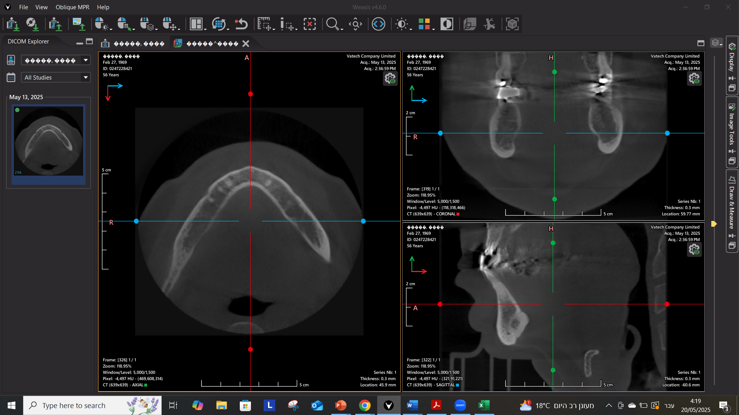
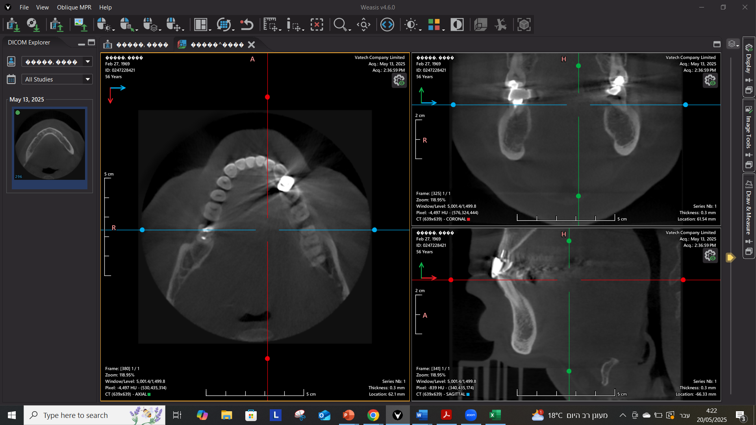
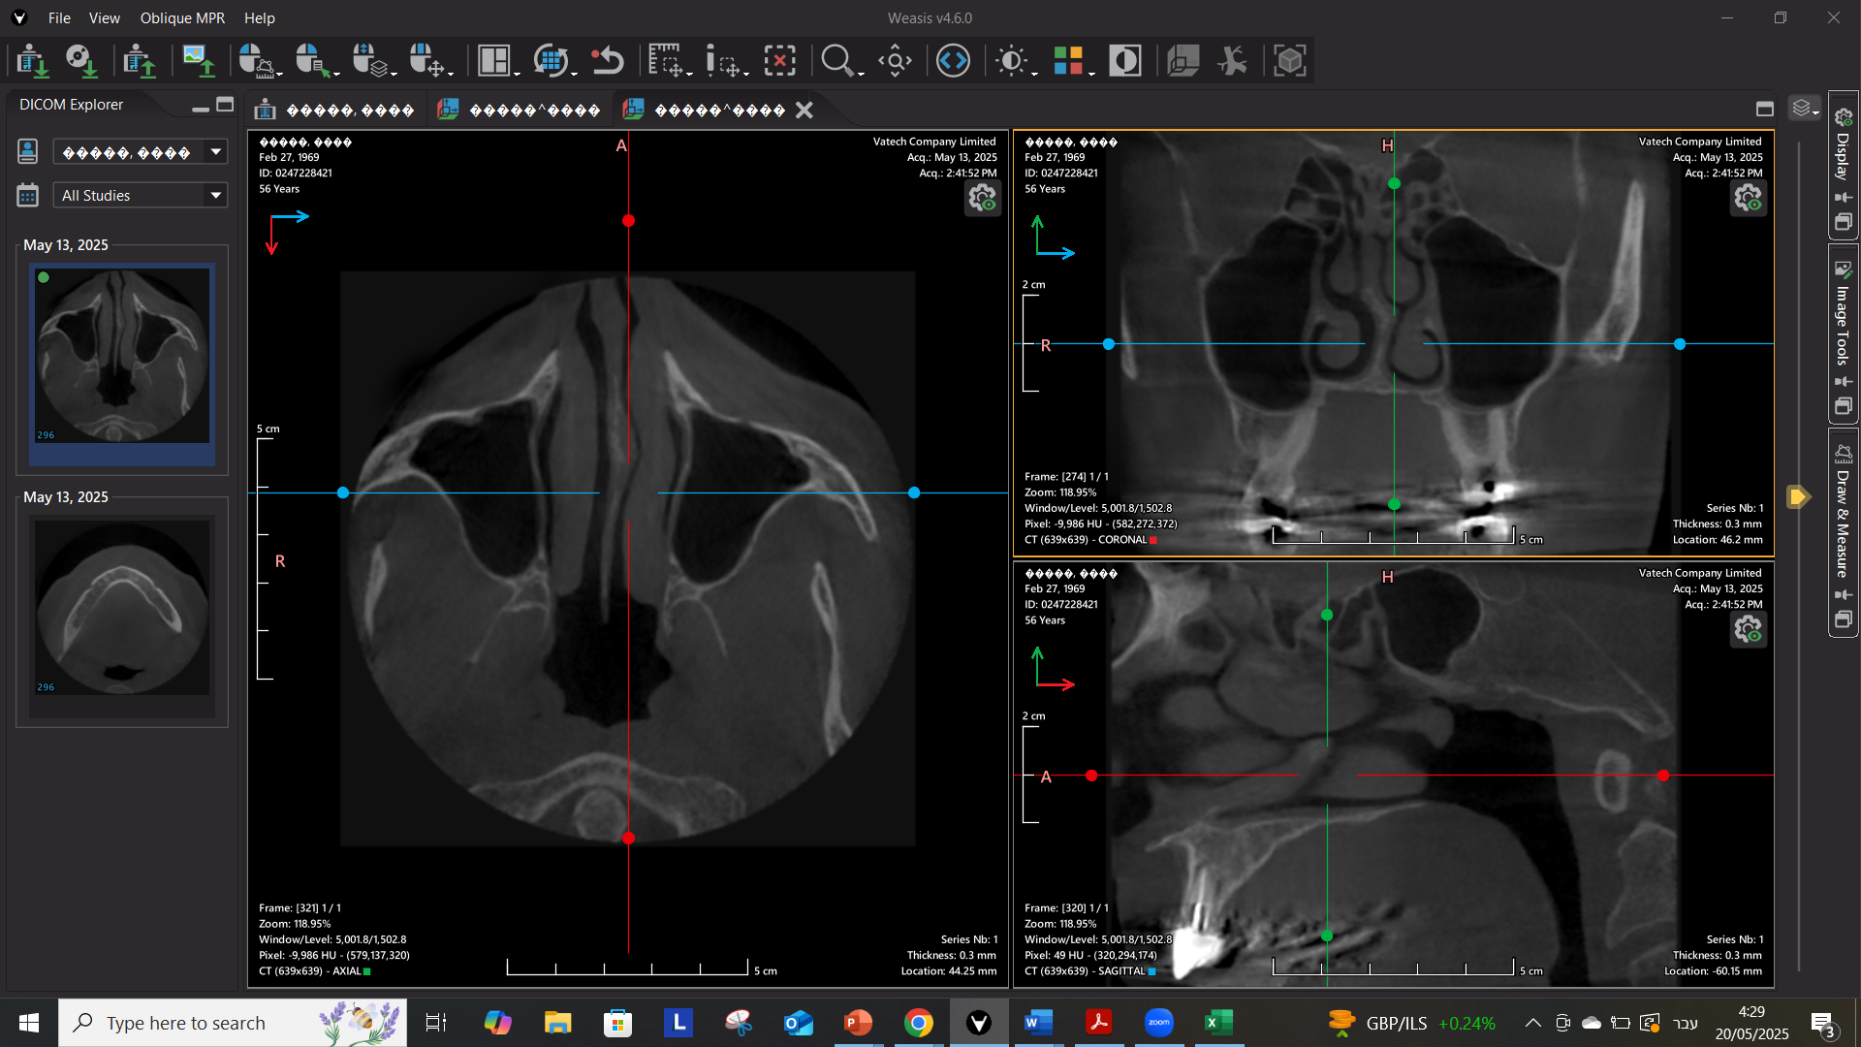


Key Observations | Details
Obstruction Sites | Velopharyngeal, oropharyngeal, and tongue base restriction.
Soft Palate & Uvula | Elongated and swollen, partially obstructing the oropharynx.
Tongue Position | Large, posteriorly positioned tongue base encroaching the airway.
Bite & Jaw Structure | Normal range overjet and overbite.
Hyoid Bone | Positioned significantly inferior to the mandibular plane.
Conclusion: The provided imaging data suggests potential airway obstruction primarily attributed to anatomical factors, including soft tissue hypertrophy, posterior tongue positioning, and a low hyoid bone position.
Possible Treatment Considerations
- An oral appliance with mandibular advancement may enhance upper airway patency and stability, particularly in the presence of trapdoor epiglottic collapse, soft tissue hypertrophy, and a large, posteriorly positioned tongue.
- Anterior and posterior vertical opening may support airway patency by creating additional space for tongue repositioning and distancing the soft palate from the pharyngeal wall.
Device Design Data Considerations
Parameter | Data-Based Consideration
Mandibular Advancement | +1mm from edge-to-edge positioning
Vertical Opening | 5mm anterior
Anterior Window | Large, allowing tongue access to upper incisors
Retention Features | Ball clasps for future adjustments, elastic hooks for stabilization
Material | High-density acrylic (hygienic, adjustable)
Pre-set | +1mm initial mandibular advancement
Anterior Acrylic | No labial coverage on anterior teeth 6-11; cover incisal edges only
Coverage | Full coverage
Clinical Notes | Consider using nose cones from the beginning of appliance use, and avoid elastic bands to preserve mandibular downward movement and allow for maximal tongue advancement.

Recommendations for Further Evaluation
- Encourage positional therapy to minimize supine sleep time, as supine AHI was consistent with severe OSA.
- A follow-up ENT evaluation may be considered approximately 3 months after initiating oral appliance therapy to reassess upper airway status.
- Consider repeating a sleep study in three months while using the oral appliance to evaluate treatment effectiveness.
- If symptoms persist despite therapy, consider a follow-up DISE with the appliance in place to assess airway dynamics and guide further treatment adjustments.
Oral Appliance Options for Consideration
Device |  | Key Features
Emerald Herbst | 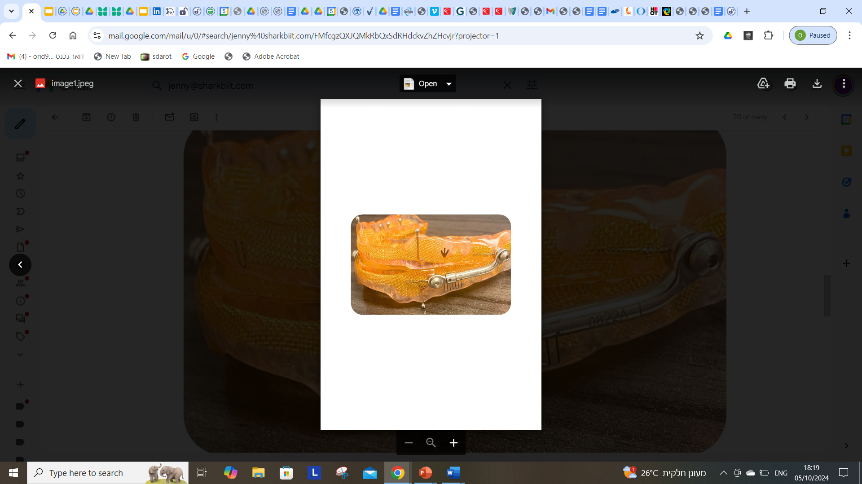 | Strong, lightweight, durable, high-density acrylic for hygiene
Respire Herbst Pink AT | 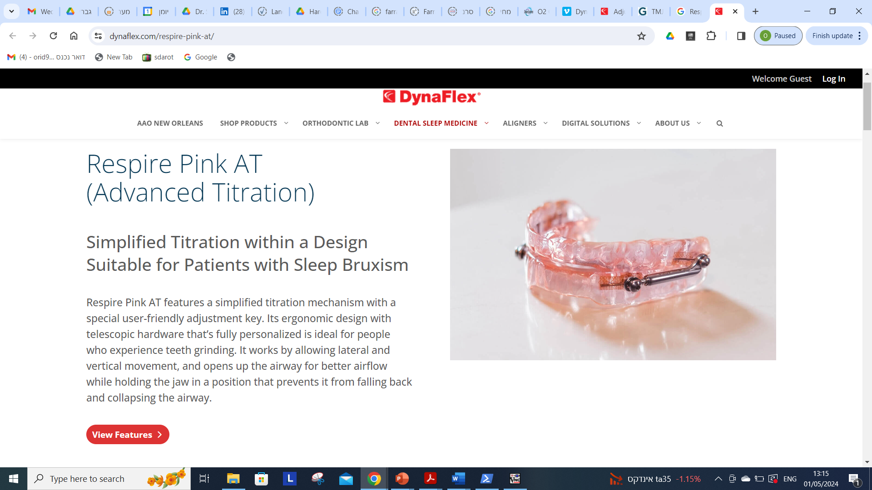 | Promotes mandible stabilization, high-density acrylic, metal mesh embedded
Daynaflex Herbst | 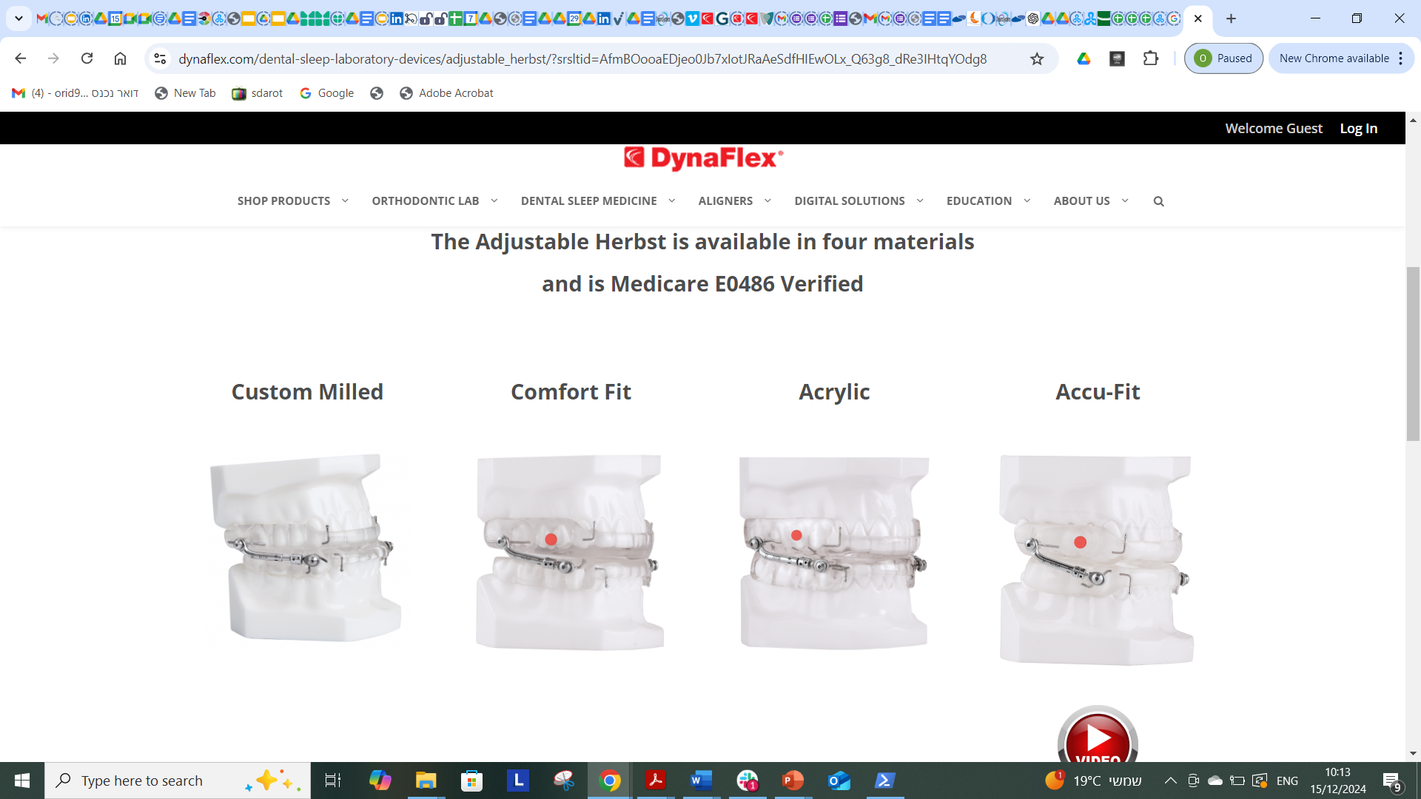 | Accurate fit, enhanced tongue space, stain-resistant PMMA
Disclaimer
This AI-generated report is intended as a data assessment tool to support clinical decision-making. It does not constitute a medical diagnosis, treatment recommendation, or radiological interpretation. All imaging findings, including CBCT references, should be reviewed and confirmed by a certified radiologist or qualified healthcare provider. Final treatment decisions must be made by licensed professionals based on a comprehensive clinical evaluation. No liability is assumed for medical decisions made solely on the basis of this report.

